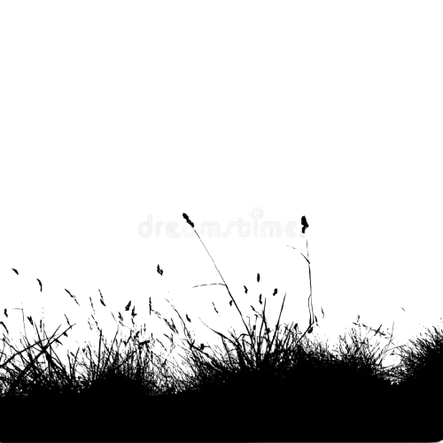


U N F E L T
Love doesn’t end in a moment.
It fades, unnoticed – until it’s gone
AUTHOR NAME

